***Control and Monitoring System for Black Soldier Fly Egg Production   
based on Internet of Things (IoT)***

Benny Hartanto S., Ari Sriyanto N., Sindung H.W.S.,  
Endro Wasito, Arif Nursyahid, Abu Hasan  
Jurusan Teknik Elektro, Program Studi S.Tr Teknik Telekomunikasi, Politeknik Negeri Semarang,  
Jl. Prof. Sudarto, Tembalang, Kec. Tembalang, Kota Semarang, Jawa Tengah, 50275

**Abstract – Waste management, particularly food waste, has become a significant focus in Indonesia and other nations. The government, especially the Ministry of Environment and Forestry, is making efforts to educate the public and landfill operators about converting food waste into alternative animal feed. Black Soldier Fly (BSF) larvae offer potential as efficient decomposers of food waste [1]. This research aims to design an IoT system for controlling and monitoring the environmental conditions in the BSF breeding facility, integrating with the Telegram platform. The system controls a water pump and fertilization lamp, featuring a hybrid mode, allowing manual control via GPIO switches and automatic control through the Telegram bot. With this prototype, water spraying in the BSF breeding facility can be automatically scheduled using the programming logic in the Telegram bot, conserving water compared to conventional methods. The use of the fertilization lamp actuator helps BSF larvae to maintain normal activity under low light conditions [2]. This study follows the Software Development Life Cycle model, specifically the waterfall approach, including phases of observation, requirements analysis, design, implementation, testing, and results analysis [3]. Hardware testing results confirm the prototype's effectiveness in manually and automatically controlling actuators via the Telegram bot. Testing data shows an average temperature of 32°C, humidity of 60.8%, and light intensity of 15004lx, indicating a favorable environmental standard. The produced egg weight ranges from 0.25 grams to 11 grams.**

* 1. INTRODUCTION
  2. *Background*

The issue of waste management is a problem experienced by all countries, whether they are developed or developing, as exemplified by Indonesia. According to the Republic of Indonesia Law Number 18 of 2008 concerning Waste Management, waste is defined as the residue from human daily activities and/or natural processes that is in solid form. This waste is generated by humans during their daily activities [4].

The nature of waste can be categorized into two main types: organic waste and inorganic waste. Organic waste is waste that can decompose and break down naturally in the environment with the assistance of decomposing organisms such as animals and insects. In contrast, inorganic waste cannot be broken down by the environment as quickly as organic waste, and it may take thousands of years to degrade into soil. Therefore, inorganic waste needs to be collected and processed (recycled) to be transformed either into the same materials or into different objects that can be reused by humans [5].

According to data from the Ministry of Environment and Forestry (KLHK), Indonesia generated a total of 21.88 million tons of waste in 2021. This amount represents a decrease of 33.33% compared to the previous year when the waste generation was 32.82 million tons. This trend is in contrast to the year 2020 when waste generation increased by 12.63%. In 2019, the total waste generated was 29.14 million tons. When analyzed by region, Central Java emerged as the province with the largest waste generation in Indonesia in 2021, totaling 3.65 million tons. It was followed by East Java with 2.64 million tons of waste [6].

Given the significant amount of food waste, the Government, especially the Ministry of Environment and Forestry (KLHK), has made it a crucial focus to educate both the general public and Landfill Operators (TPA) on solutions for processing food waste into organic products that can be utilized as an alternative source of animal feed. This animal feed source refers to the larvae or maggots of the Black Soldier Fly (BSF) insect, scientifically known as Hermetia illucens L. or commonly referred to as the Black Soldier Fly. The BSF larvae are capable of decomposing food waste in just a few days, depending on the size of the breeding facility where the flies are placed. As they progress from the prepupal stage to become mature BSF flies, they stop feeding and eventually die after completing their reproductive cycle, with male flies dying after mating and female flies dying after laying eggs [7].

The Internet of Things (IoT) is a concept where objects or devices are embedded with technologies such as sensors and software for the purpose of communication, control, and data exchange with other devices as long as they remain connected to the internet. IoT is closely related to the term machine-to-machine (M2M). All devices with M2M communication capabilities are often referred to as smart devices. These smart devices are expected to assist humans in completing various tasks and activities, making daily life more convenient and efficient.[2].

* 1. *Literature Reviews*

To create a device with a control and monitoring system, it is essential to conduct a thorough study of the relationship between previous research and the current project. Ideally, this is done to identify the strengths and weaknesses of prior research, which can be sourced from scientific journals or specific books. In addition to assessing strengths and weaknesses, other reference points may include the technology used, additional materials acquired, testing parameters, and more, as outlined in Table 1. This comprehensive analysis helps in building upon existing knowledge and improving the design and functionality of the new device.

Table 1 References for literature review in system development

|  |  |  |  |
| --- | --- | --- | --- |
| No | Nama Artikel | Deskripsi Penelitian | Keterangan |
| 1. | *Black Soldier Fly rearing with artificial light: how to ensure mating success and fertile eggs* (Swiss Federal Institute of Aquatic Science and Technology, Eawag) | The process of testing Black Soldier Flies (BSF) using SolarRaptor artificial lights to assess the efficiency factor of reproductive activities | The testing was conducted within the research facility at Eawag in Switzerland, employing various different types of artificial lights to investigate the effects of artificial lighting on the reproductive activities of BSF |
| 2. | *Black Soldier Fly* (*Hermetia illucens*) sebagai Sumber Protein Alternatif untuk Pakan Ternak (April Hari Wardhana, 2017) | Collecting facts from previous research on the morphology and life cycle, nutritional content, utilization as animal feed, and economic analysis of Black Soldier Flies (BSF) | The collected facts form a dataset that can comprehensively and in detail explain Black Soldier Flies (BSF) as well as the benefits that humans can derive from them |
| 3. | *Automated IoT Device to Manipulate Environmental Condition of Black Soldier Fly* (Kevin Kristianto, Ronaldo Vieri Lambert, Abba Suganda Girsang. Maret, 2022) | Manipulating the environmental conditions in the location where Black Soldier Flies (BSF) are situated to maximize egg production using BH1750 and DHT11 sensors, with the output being the control of a warming bulb and exhaust fan | The discussion provides an explanation of the table illustrating the testing of the room conditions with the installed output and the room conditions without any output. Additionally, it presents the results of the eggs that have been produced. |

* 1. RESEARCH METHOD
  2. *Research Methodology*

The research method employed in the preparation of this final project is the Software Development Life Cycle (SDLC) model known as the waterfall model. The SDLC method itself represents the process of creating and modifying systems, as well as the models and methodologies used for engineering software systems in product development. On the other hand, the waterfall model is a working method that emphasizes sequential and systematic phases. It is called "waterfall" because the process flows in one direction, like a waterfall. The waterfall method must be executed sequentially in accordance with the existing stages [3].

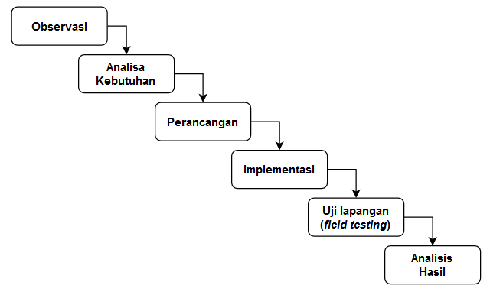

Figure 1: SDLC waterfall research methodology

Based on what is observed in Figure 1, the stages of the SDLC waterfall research methodology consist of: observation, requirement analysis, design, implementation, field testing, and result analysis.

* 1. SYSTEM DESIGN
  2. *Overall System Design*

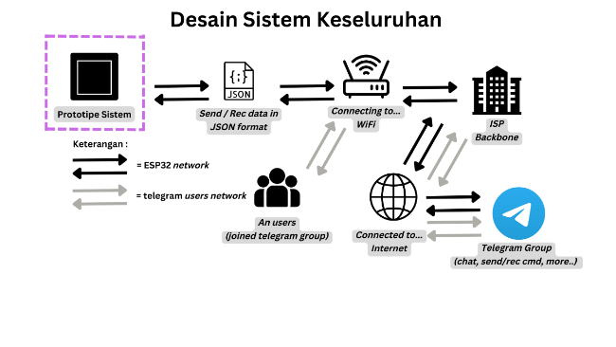

Figure 2: Overall system design  
(Author’s Doc.)

In Figure 2, it can be seen that there are two different networks. Both of these networks are directed towards the same destination, which is the Telegram group, through their respective internet backbone connections via WiFi. The system prototype sends and receives data from Telegram bot commands using string data converted into JavaScript Object Notation (JSON) format for ease of parsing. Parsing itself is the process of reading JSON format, which can be performed both server-side and client-side and is compatible with various programming languages, especially C++.

In simple terms, the creation of a Telegram group integrated with a Telegram bot facilitates communication among Black Soldier Fly farmers and group members. This allows them to use the built-in features of the Telegram application for chatting, file uploading, polling, voice notes, and, in addition, the integration of Telegram bot commands for monitoring temperature, humidity, light intensity, and controlling the water pump and fertilizer lamp, both manually and automatically.

* 1. *System Prototype Block Diagram*

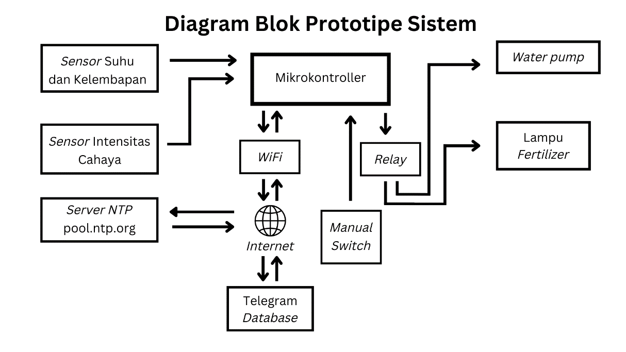

Figure 3: Block diagram of the system prototype (Author's Doc.)

The ESP32 microcontroller will serve as the data coordinator responsible for retrieving values from sensors, including temperature, humidity, light intensity, and real-time data from an NTP server. Regarding the NTP server, the ESP32 must first establish an internet connection via a predefined WiFi network. When connected to the Telegram database, the ESP32 will be recognized by the Telegram API database based on the BOT_TOKEN and CHAT_ID. This recognition enables the ESP32 to identify and execute user-sent commands through the Telegram application. For example, it can turn the water pump and fertilizer lamp on or off, both automatically and manually, with the assistance of a relay to trigger LOW or HIGH conditions. Additionally, there will be two buttons or switches that can be operated in a hybrid manner, including a Telegram bot switch and a manual switch. The inclusion of a manual switch aims to prevent malfunctions when the internet connection is poor, ensuring that the system can still be operated manually.

* 1. Wiring Diagram

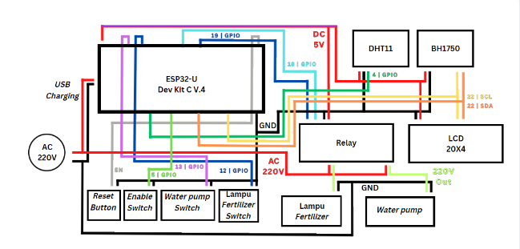

Figure 4: Wiring diagram or component wiring (Author's Doc.)

In Figure 4, each component connects to the ESP32 as the power source and central control unit. Generally, 2 to 4 pins must interconnect with each component, including positive (+) and negative (-) terminals, GPIO sensor pins, SDA SCL pins, and other relevant connections.

It is essential to note that various ESP32 models available in different electronic stores may exhibit output voltage levels on the 3.3V and 5V pins lower than recommended specifications. This circumstance can lead to voltage drops, potentially resulting in inaccuracies in sensor readings, the inability of switches or relays to transition between LOW and HIGH conditions, or vice versa. Furthermore, it may cause the ESP32 to become unresponsive until the connections to the components are disconnected. To mitigate this issue, following the completion of the wiring process, ensure that the output voltage aligns with the specified specifications. Verification can be performed using either a digital or analog multimeter. If the voltage remains inadequate, a DC boost converter can be employed as a solution.

* 1. TEST RESULTS AND ANALYSIS
  2. *Hardware Testing Results*

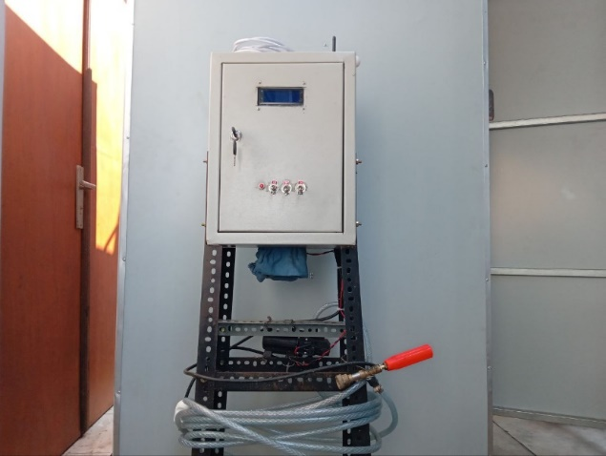

Figure 5: Results of the IoT System Prototype Design (Author's Doc.)

In Figure 5, the results obtained depict the creation of a prototype IoT system design developed using the SDLC waterfall research methodology. This prototype system is of a hybrid nature, which means it can be controlled manually via GPIO Switches or automatically through a WiFi connection linked to the internet, facilitated by Telegram bot commands.

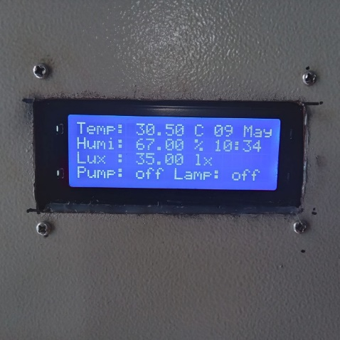

Figure 6: Output results on the LCD screen (Author's Doc.)

For monitoring the sensor reading results, you can directly observe them on the 20x4 LCD screen in Figure 6. The LCD screen displays parameters such as temperature, humidity, light intensity, and the status of the water pump and fertilizer lamp actuators.

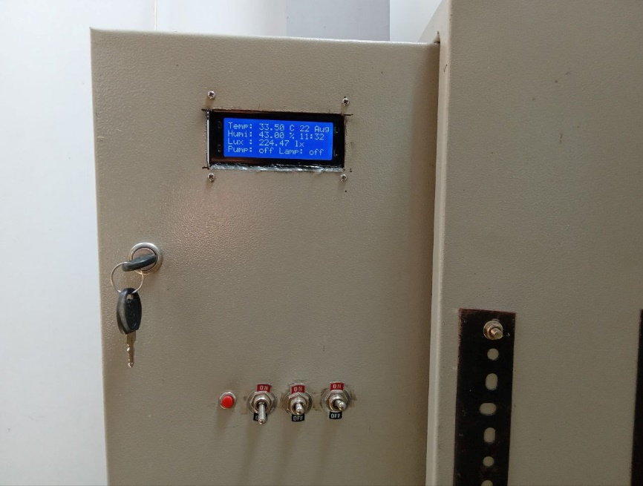

Figure 7: Buttons and switches on the prototype device (Author's Doc.)

As depicted in Figure 7, the prototype device is also equipped with manual controls that can manage several functions on the prototype device. These include the reset button, take-over switch, water pump switch, and fertilizer lamp switch.

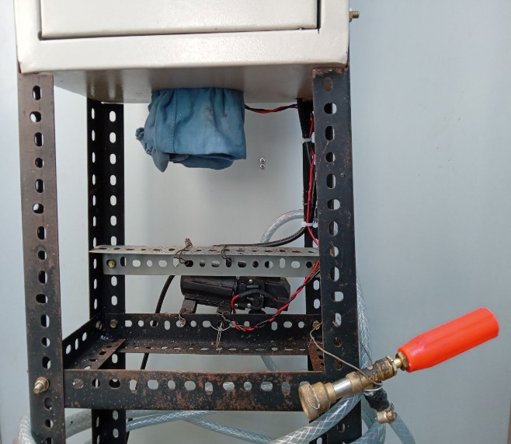

Figure 8: Water pump control device on the prototype (Author's Doc.)

In Figure 8, there is a water pump connected to a sprinkler that generates high-pressure spraying, controlled by the state of a relay acting as an actuator.

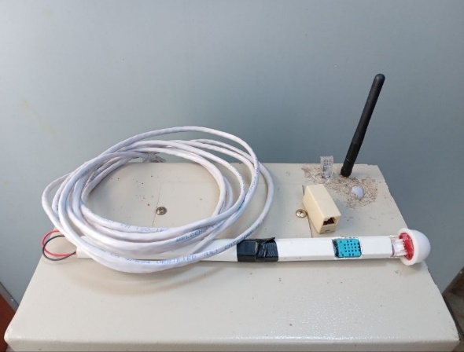

Figure 9: Sensor components of the prototype device (Author's Doc.)

In Figure 9, there are two types of sensors available on the prototype device: the DHT11 sensor, which reads temperature and humidity parameters, and the BH1750 sensor, capable of measuring light intensity. Both sensors are connected using Ethernet cables and are placed inside the Black Soldier Fly breeding enclosure.

* 1. *Software Testing Results*



Figure 10: Part 1 of the Telegram bot application usage (Author's Doc.)

In addition to displaying output results on the LCD screen in Figure 10, this device can also present them in the form of response messages through the Telegram bot. The bot is named "BSF Control Tools." When a user sends a message such as "/start@bsfcontrol_bot," the bot responds by indicating its readiness for use.

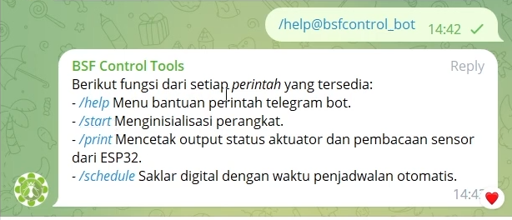

Figure 11: Part 2 of the Telegram bot application usage (Author's Doc.)

When a command message is entered as "/help@bsfcontrol_bot," the bot responds by displaying options consisting of available features within Telegram provided by the prototype device, as shown in figure 11.

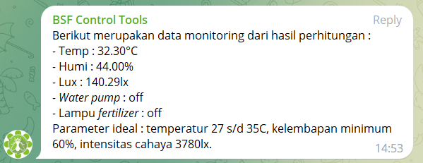

Figure 12: Part 3 of the Telegram bot application usage (Author's Doc.)

When a command message is received as "/print@bsfcontrol_bot," the bot will print the same output results as displayed on the 20x4 LCD screen on the panel box. Additionally, the device's controlled conditions for the water pump and fertilizer lamp are named "off" when they are in the off state and "on" when they are in operational mode, as indicated in Figure 12.

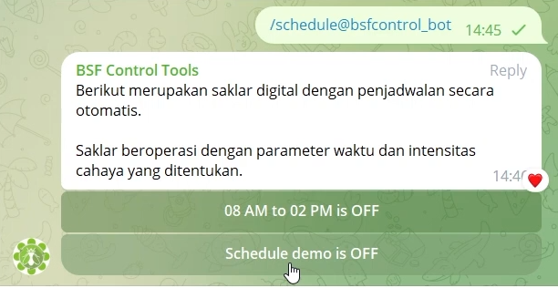

Figure 13: Part 4 of the Telegram bot application usage (Author's Doc.)

When a command message is entered as "/schedule@bsfcontrol_bot," the bot will set the actuator conditions to operate at the specified times as selected from the scheduling options, as seen in Figure 13.

The first button will control the conditions of the water pump and fertilizer lamp actuators to turn on every day from 09:00 to 14:00. The water pump will operate for 15 seconds during the first minute and then stop, repeating this cycle for the next 30 minutes before turning on again. As for the fertilizer lamp, it will only turn on if the light intensity drops below 3780lx.

The second button follows a similar pattern, with the water pump running for 15 seconds and then off for 45 seconds, repeating the initial cycle. Likewise, the fertilizer lamp will only turn on when the light intensity drops below 3780lx.

* 1. *Simulation Testing Results*

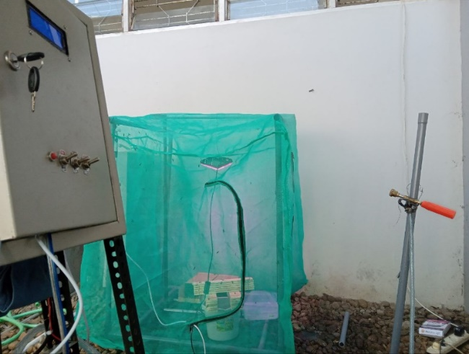

Figure 14 Simulation testing of the prototype system (Author's Doc.)

In Figure 14 above, the prototype device is being tested in an enclosed room to ensure its functionality. In the enclosed room, DHT11 and BH1750 sensors are installed in the left corner, while on the right side, there are two types of controlled devices, namely the fertilizer lamp and water pump. The testing conducted aims to verify whether the promised hybrid mode truly functions by manually activating it using the GPIO switch and automatically through the scheduling logic of the Telegram bot. The automatic mode operates within the time range of 09:00 to 14:00 with a 15-second interval every 30 minutes for the water pump. The fertilizer lamp will turn on if the lux value falls below 3780lx.

Based on Table 2 below, it presents the data from the simulation testing of the prototype device.

Table 2 Prototype device functionality testing

|  |  |  |  |
| --- | --- | --- | --- |
| **Test no** | **Function Test** | **Success** | **Failed** |
| 1. | The take-over switch serves the function of switching control between the GPIO switch control mode and the Telegram bot control mode. | ✓ |  |
| 2. | Turning on and operating the water pump and/or fertilizer lamp through the GPIO switch. | ✓ |  |
| 3. | Automatically turning on and off the water pump through Telegram bot based on scheduling logic. | ✓ |  |
| 4. | Automatically turning on and off the fertilizer lamp through Telegram bot based on the sensor readings threshold values in the scheduling logic. | ✓ |  |
| 5. | *The reset push button functions to return the device to its initial state in case of errors or malfunctions in the prototype device* | ✓ |  |

Based on the simulation results presented in Table 2, the testing demonstrates that the prototype device can be operated in hybrid mode. By using the take-over switch, the device can switch between control modes, either directly controlled by the GPIO switch or scheduled control through the Telegram bot.

In the Telegram bot mode, the scheduling logic functions effectively, ensuring that the water pump and fertilizer lamp actuators operate within the time range from 09:00 to 14:00. In the case of the controlled fertilizer lamp, it will only turn on during the specified time if the sunlight intensity, as read by the BH1750 sensor readings, drops below the minimum threshold of lux < 3780lx. When the sunlight intensity rises above the threshold, the lamp will turn off again.

The reset push button serves as a button used to return the prototype device to its initial programmed state. This serves as a preventive measure in case any issues arise within the system, making it easier to handle by simply pressing the button.

* 1. *Testing and Analysis Findings*

Based on the field testing data conducted within the timeframe from June 5 to June 16, 2023, various data points have been obtained to provide an understanding of the measured patterns within the same testing environment, by comparing two different time periods. The difference being compared is between the parameter values measured directly in the first week and the parameter values measured using the prototype device in the second week. Below, data from Tables 3 to 5 will be presented, which are related to sensor reading results, weather, and Black Soldier Fly egg production outcomes.*.*

Table 3 DHT11 Temperature Sensor Readings Testing

|  |  |  |
| --- | --- | --- |
| **Date** | **Time** | **Sensor readings temperature DHT11 (****°C)** |
|
| 05 Jun | 09:00 | 32,4 |
| 14:00 | 29,1 |
| 06 Jun | 09:00 | 33,3 |
| 14:00 | 28,5 |
| 07 Jun | 09:00 | 31,9 |
| 14:00 | 32,6 |
| 08 Jun | 09:00 | 31,5 |
| 14:00 | 33,2 |
| 09 Jun | 09:00 | 29,2 |
| 14:00 | 33,6 |
| 12 Jun | 09:00 | 31,5 |
| 14:00 | 34,4 |
| 13 Jun | 09:00 | 31,6 |
| 14:00 | 33,6 |
| 14 Jun | 09:00 | 31,6 |
| 14:00 | 36,1 |
| 15 Jun | 09:00 | 28,1 |
| 14:00 | 34,8 |
| 16  Jun | 09:00 | 30,5 |
| 14:00 | 32,2 |
| **Max** | | **36,1** |
| **Min** | | **28,1** |
| **Avg** | | **32,1** |

The testing table in Table 3 is used to collect data on temperature changes that occur in the environment around the BSF fly breeding area. Based on this data, it can be determined whether the environment is ideal or not for BSF flies to carry out the reproduction process.

Figure 15 Temperature measurement data (Author's Doc.)

In Figure 15, from the temperature testing results with 20 different samples, the sensor readings from DHT11 showed a maximum temperature value of 36.1°C, a minimum value of 28.1°C, and an average value of 32°C. This falls within the "good" category, where the recommended temperature range is a minimum of 27°C and a maximum of 36°C [8].

Table 4 DHT11 Temperature Sensor Readings

|  |  |  |
| --- | --- | --- |
| **Date** | **Time** | **Sensor readings humidity DHT11 (%)** |
|
| 05  Jun | 09:00 | 73 |
| 14:00 | 75 |
| 06  Jun | 09:00 | 61 |
| 14:00 | 76 |
| 07  Jun | 09:00 | 61 |
| 14:00 | 61 |
| 08  Jun | 09:00 | 68 |
| 14:00 | 51 |
| 09  Jun | 09:00 | 66 |
| 14:00 | 48 |
| 12  Jun | 09:00 | 68 |
| 14:00 | 53 |
| 13  Jun | 09:00 | 79 |
| 14:00 | 71 |
| 14  Jun | 09:00 | 66 |
| 14:00 | 52 |
| 15  Jun | 09:00 | 67 |
| 14:00 | 62 |
| 16  Jun | 09:00 | 73 |
| 14:00 | 56 |
| **Max** | | **82** |
| **Min** | | **46** |
| **Avg** | | **60,8** |

The testing table in Table 4 is used to collect data on humidity changes that occur in the environment around the BSF fly breeding area. Based on this data, it can be determined whether the environment is ideal or not for BSF flies to carry out the reproduction process.

Figure 16: Humidity measurement data (Author's Doc.)

In Figure 16, from the temperature testing with 20 different samples, the sensor readings of the DHT11 showed a maximum humidity value of 82%, a minimum value of 46%, and an average value of 60.8%. If we consider the average humidity value, it falls within the acceptable range, as the recommended humidity level is 80%, with a minimum threshold of 60%.[9].

Table 5 Testing of BH1750 light intensity sensor readings

|  |  |  |
| --- | --- | --- |
| **Date** | **Time** | **Sensor readings light intenisty BH1750 (lx)** |
| 05  Jun | 09:00 | 13256 |
| 14:00 | 7858 |
| 06  Jun | 09:00 | 10243 |
| 14:00 | 5439 |
| 07  Jun | 09:00 | 19943 |
| 14:00 | 7224 |
| 08  Jun | 09:00 | 12282 |
| 14:00 | 14944 |
| 09  Jun | 09:00 | 8464 |
| 14:00 | 16845 |
| 12  Jun | 09:00 | 12282 |
| 14:00 | 27969 |
| 13  Jun | 09:00 | 8042 |
| 14:00 | 8379 |
| 14  Jun | 09:00 | 14646 |
| 14:00 | 17700 |
| 15  Jun | 09:00 | 9334 |
| 14:00 | 21976 |
| 16  Jun | 09:00 | 10412 |
| 14:00 | 44949 |
| **Max** | | **44949** |
| **Min** | | **5439** |
| **Avg** | | **14609** |

The table in Table 5 is used to collect data on changes in sunlight intensity in the environment around the BSF fly breeding facility. Based on this data, it can be determined whether the environment is suitable or not for BSF flies to carry out their reproduction process.

Figure 17 Data measurement of light intensity (Author's Doc.)

From the temperature testing results, which involved 20 different samples, the sensor readings from BH1750 indicated a maximum sunlight intensity of 46,164lx, a minimum of 5,586lx, and an average value of 15,004lx. Therefore, it can be determined that the average value of 15,004lx is considered a good level of light intensity, especially considering that the testing was conducted during the dry season, when sunlight tends to be stronger compared to the rainy season. On the other hand, a poor light intensity level is defined as less than 3,780lx [10].

Table 6 Field testing without interaction by the prototype device

|  |  |  |  |  |  |  |
| --- | --- | --- | --- | --- | --- | --- |
| **Date** | **Time** | **Sensor readings inside the prototype device** | | | **Real time Weather** | **Egg Production  (grams)** |
| **Temp (°C)** | **Humidity (%)** | **Light intensity (lx)** |
| 05  Jun | 09:00 | 30,7 | 60 | 13614 | 3 (overcast) | 11 |
| 06  Jun | 09:00 | – | – | – | – | – |
| 07  Jun | 09:00 | 31,9 | 62 | 20482 | 3 (overcast) | 6 |
| 08  Jun | 09:00 | – | – | – | – | – |
| 09  Jun | 09:00 | 29,2 | 63 | 8693 | 4 (clear) | 2 |

Based on the test results in Table 6, the BSF fly eggs were obtained in quantities of 11 grams, 6 grams, and 2 grams during 1 week of testing without any interaction by the prototype device. The temperature, humidity, and light intensity data can be found in tables 3, 4, and 5, respectively. Meanwhile, real-time weather data was obtained through direct observations using sensors.

Table 7 Field testing with interaction by the prototype device

|  |  |  |  |  |  |  |
| --- | --- | --- | --- | --- | --- | --- |
| **Date** | **Time** | **Sensor readings inside the prototype device** | | | **Real time Weather** | **Egg Production  (grams)** |
| **Temp (°C)** | **Humidity (%)** | **Light intensity (lx)** |
| 12  Jun | 09:00 | 31,5 | 64 | 12614 | 2  (light rain) | 2 |
| 13  Jun | 09:00 | – | – | – | – | – |
| 14  Jun | 09:00 | 31,6 | 66 | 15042 | 3  (overcast) | 2 |
| 15  Jun | 09:00 | – | – | – | – | – |
| 16  Jun | 09:00 | 30,5 | 63 | 10693 | 3  (overcast) | 0,25 |

Based on the results of the testing presented in Table 7, it was found that the BSF fly egg production was 2 grams, 2 grams, and 0.25 grams over a period of 1 week of testing with the interaction of the prototype device. The temperature, humidity, and light intensity data were obtained from Tables 3, 4, and 5, respectively. Real-time weather information was gathered through direct observations using a weather instrument.

Figure 18 Real-time weather monitoring with senses (Author's Doc.)

In Figure 18, the real-time weather index values were obtained by observing the outdoor location of the testing using the Pancaindra eye during the egg harvesting process. As seen in the trend graph above, the weather index values range from 3, then rise to 4, peaking at 5, and predominantly staying at 4. The meanings are as follows: 1 signifies heavy rain, 2 signifies light rain, 3 signifies overcast, 4 signifies clear, and 5 signifies scorching heat. From the information above, it can be concluded that the testing occurred during the dry season, and the results would differ if the rainy season were to occur.

.

Figure 19 depicts the quantity of egg production in milligrams (Author's Doc.)

In Figure 19, the total weight of black soldier fly eggs harvested is displayed. When examining the trend graph above, it can be observed that the egg count starts at 11 grams, decreases to 6 grams, and further declines to 2 grams for the testing without any interaction with the prototype device during the first week of testing, as indicated in Table 4.7. In the second week, the egg count stabilizes around 2 grams and then drops to 0.25 grams (adjusted result) as per Table 7.

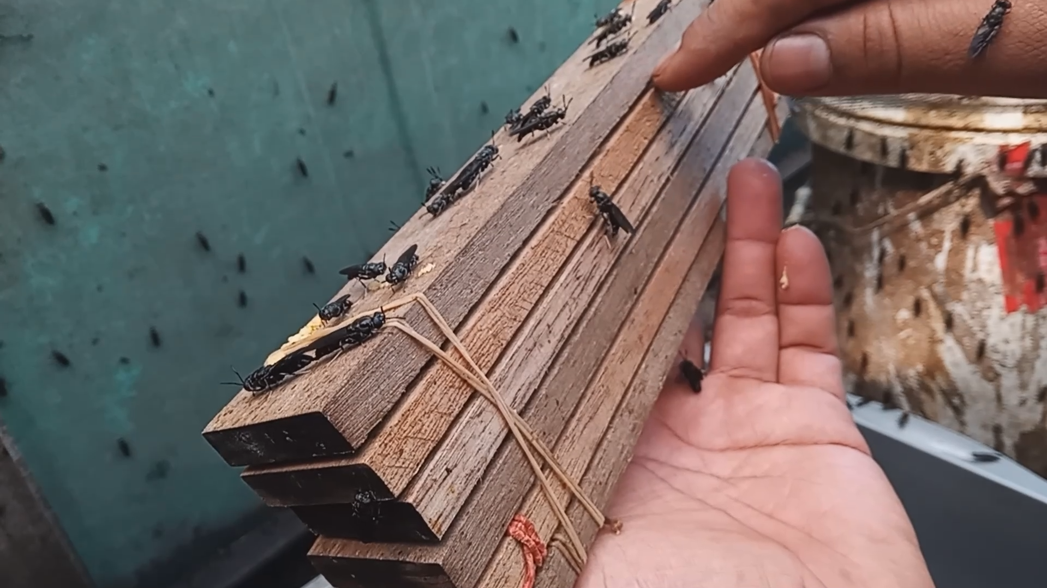

Figure 20: Wooden blocks for bsf egg laying (Author's Doc.)

In Figure 20, the wooden blocks are neatly arranged in 6 levels and held together by rubber bands. Each narrow gap on every level contains small umbrella nails with a thickness of approximately 0.2 cm. These fly eggs were obtained from a single enclosure that had been quarantined, with egg collection occurring every 2 days. The collected eggs were placed on a set of small wooden blocks with multiple tiers, where the flies laid their eggs, as indicated in testing tables 7 and 8.

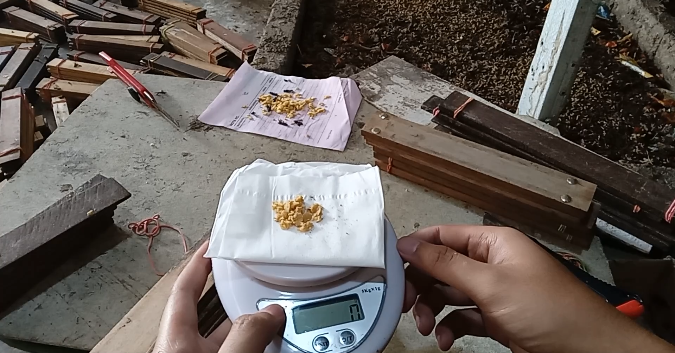

Figure 21 shows the weighing process of black soldier fly eggs (Author's Doc.)

In Figure 21, the results of the final testing in the second week are shown. If observed, the amount of eggs obtained is less than 0 grams. This is due to several challenges during the testing, including the fact that the Black Soldier Fly (BSF) enclosure started to develop holes in the middle of the first week of testing. Additionally, there was a change and reduction in the number of employees from the initial 5 to 2 individuals at the testing site. This prioritized the stock of pupae ready to hatch for the main enclosure to restore the BSF reproduction cycle that had been disrupted. As a result, the BSF flies in the testing enclosure gradually died off, and there were no replacements, leading to a decrease in the amount of eggs produced to less than 1 gram.

* 1. *Testing Challenges*

During the testing, various anomalies occurred due to a range of factors, necessitating multiple modifications and adjustments during the course of the testing. The types of limitations and challenges faced during the testing are as follows:

1. Disruption of the BSF reproduction cycle, leading to the cessation of the process of pupae transitioning into adult BSF, ultimately resulting in a significant decrease in the BSF population within the enclosure, leading to reduced egg production.
2. The weather conditions in the testing environment, which were entering the dry season, limited the opportunities for the controlled fertilizer lamp device to activate. This was due to the recorded intensity levels on the BH1750 sensor, which consistently remained above 3780lx.
3. The turnover and reduction in staff to only 2 individuals slowed down business operations. This resulted in permission for testing being granted for only 1 remaining enclosure out of the total 4 enclosures. The other 4 enclosures were prioritized for the restoration of the BSF reproductive cycle and some were allocated for sale to customers.

The BSF enclosure used for testing experienced a breach on June 9, 2023, resulting in the escape of a significant number of BSF flies from the enclosure. Repairs to the enclosure were carried out two days later.

* 1. CONCLUSION

Based on the testing and analysis conducted at Rumah Maggot Kabupaten Semarang on the prototype "Black Soldier Fly Egg Production Control and Monitoring System," the following conclusions can be drawn:

1. The design and construction of the prototype system were found to function effectively. The testing included functional simulation tests of the prototype's ability to operate in hybrid mode, allowing for manual and automatic operation. This was followed by field testing of DHT11 and BH1750 sensor reading, testing without interaction by the prototype, and testing with interaction by the prototype.
2. The features offered by the prototype system include the ability to read temperature, humidity, and light intensity sensor readings. In terms of control, the prototype can control the conditions of the water pump and fertilizer lamp, both manually using GPIO switches and through scheduling using Telegram bot commands. On the monitoring side, the device can display sensor reading results and the status of controlled devices through a 20x4 LCD or via Telegram bot commands.
3. With the existence of this prototype system, high-pressure drinking water spraying in the BSF enclosure using the water pump can be performed regularly, thanks to the scheduling logic programmed in the Telegram bot commands with an operational time from 09:00 to 14:00. If manual control is desired, GPIO switches can be used. Moreover, the use of water will be more efficient compared to conventional hose spraying. As for the controlled fertilizer lamp device, it can help replace the role of sunlight when the light intensity value recorded by the BH1750 sensor reading falls below 3780lx. Thus, BSF flies can carry out their reproduction activities normally without hindrance during cloudy and rainy weather.
4. The test results data indicates that the average temperature is 32°C, the average humidity is 60.8%, and the average light intensity is 15004lx. On average, the environmental conditions around the BSF breeding enclosure are considered ideal.

Due to various unforeseen challenges during testing, the production of BSF fly eggs decreased from an initial 11 grams to 0.25 grams.

* 1. REFERENCES

[1] A. H. Wardhana, B. Besar, P. Veteriner, and J. Re, “Black Soldier Fly (Hermetia illucens) sebagai Sumber Protein Alternatif untuk Pakan Ternak (Black Soldier Fly (Hermetia illucens) as an Alternative Protein Source for Animal Feed),” vol. 26, no. 2, pp. 69–078, 2016, doi: 10.14334/wartazoa.v26i2.1218.

[2] K. Kristianto, R. V. Lambert, and A. S. Girsang, “Automated IoT Device to Manipulate Environmental Condition of Black Soldier Fly,” *International Journal of Emerging Technology and Advanced Engineering*, vol. 12, no. 3, pp. 33–40, Mar. 2022, doi: 10.46338/ijetae0322_05.

[3] R. Setiawan, “Metode SDLC Dalam Pengembangan Software,” Jul. 28, 2021.

[4] Peraturan Pemerintah RI, *Undang-undang Republik Indonesia Nomor 18 Tahun 2008 tentang Pengelolaan Sampah*. Indonesia, 2008.

[5] H. Čičková, G. L. Newton, R. C. Lacy, and M. Kozánek, “The use of fly larvae for organic waste treatment,” *Waste Management*, vol. 35, pp. 68–80, Jan. 2015, doi: 10.1016/J.WASMAN.2014.09.026.

[6] M. I. Mahdi and D. Bayu, “Indonesia Hasilkan 21,88 Juta Ton Sampah pada 2021,” Feb. 08, 2021. https://dataindonesia.id/ragam/detail/indonesia-hasilkan-2188-juta-ton-sampah-pada-2021

[7] A. D. Briscoe and L. Chittka, “The evolution of color vision in insects,” *Annual Review of Entomology*, vol. 46. 2001. doi: 10.1146/annurev.ento.46.1.471.

[8] J. K. Tomberlin, P. H. Adler, and H. M. Myers, “Development of the black soldier fly (Diptera: Stratiomyidae) in relation to temperature,” *Environ Entomol*, vol. 38, no. 3, 2009, doi: 10.1603/022.038.0347.

[9] J. K. Tomberlin and D. C. Sheppard, “Factors influencing mating and oviposition of black soldier flies (Diptera: Stratiomyidae) in a colony,” *J Entomol Sci*, vol. 37, no. 4, 2002, doi: 10.18474/0749-8004-37.4.345.

[10] D. C. Sheppard, J. K. Tomberlin, J. A. Joyce, B. C. Kiser, and S. M. Sumner, “Rearing methods for the black soldier fly (diptera: Stratiomyidae),” *J Med Entomol*, vol. 39, no. 4, 2002, doi: 10.1603/0022-2585-39.4.695.